Windows Registry Assignment and Exercise

1-back up the Registry before opening the Registry Editor.

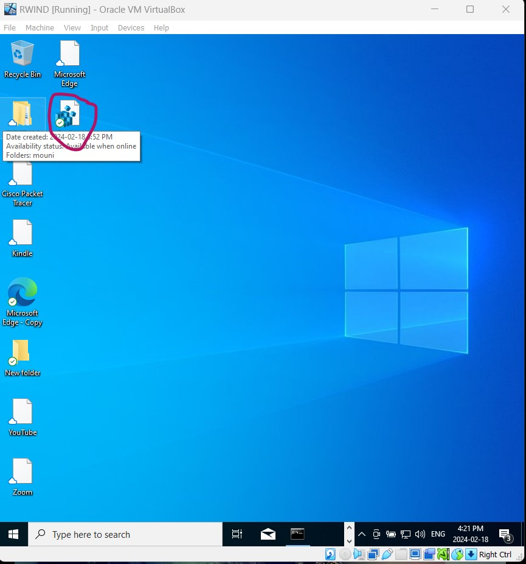

2-View the current value for MouseTrails registry settings.

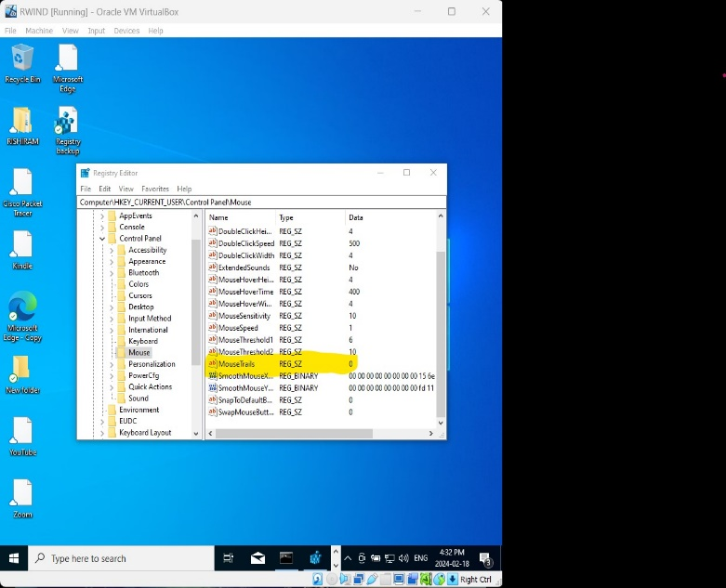
- Open the Run dialog box and enter regedit

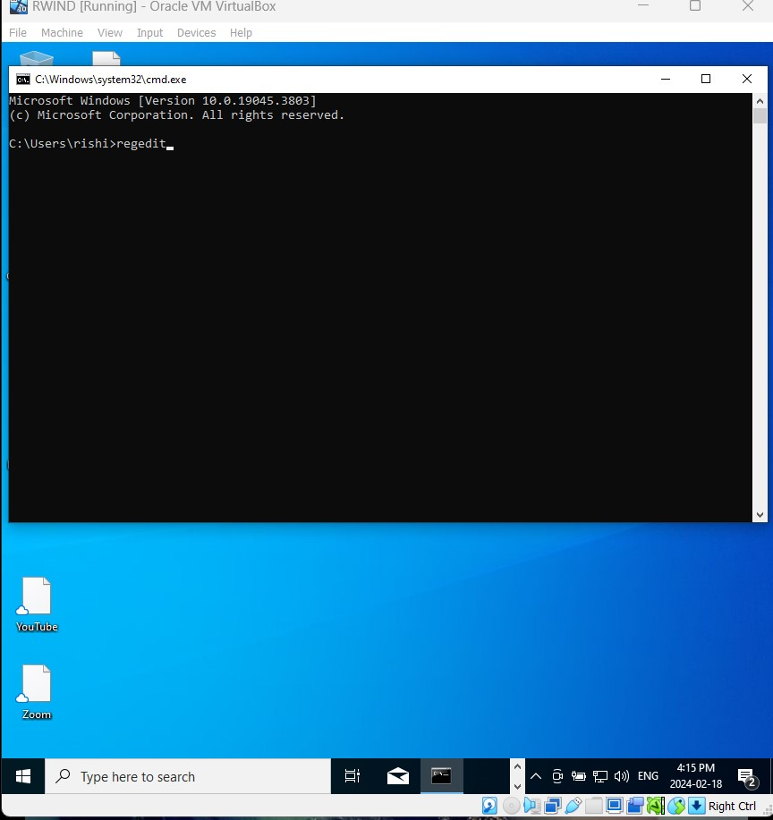

- If prompted for Administrative access, select Yes.
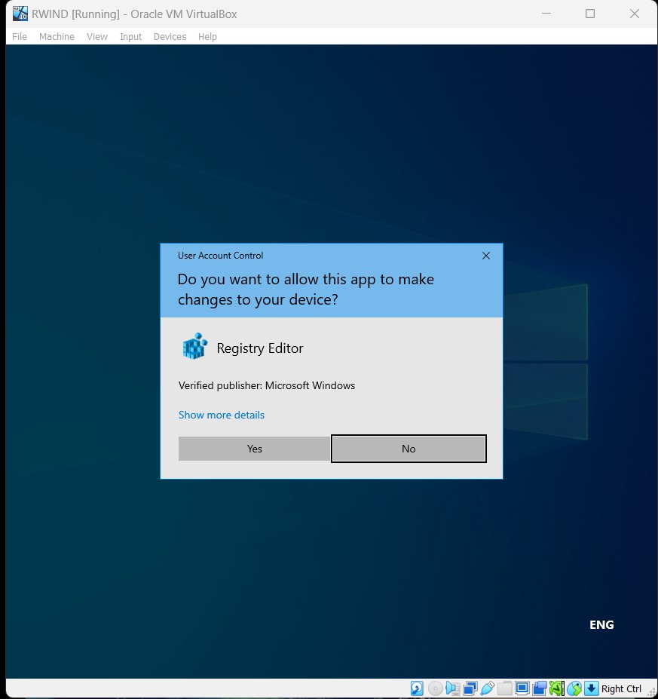

- In the Registry Editor window, select Edit→Find. In the Find dialog box, enter mousetrails
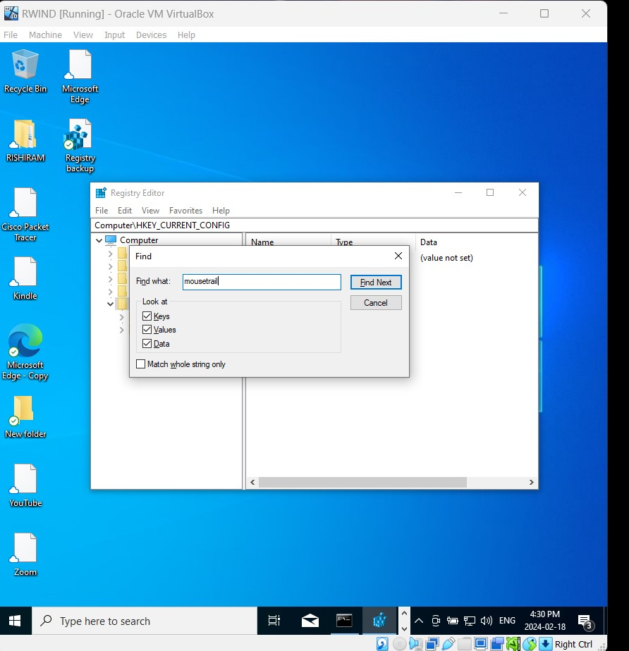

- Observe the current value for MouseTrails. It should currently have a 0 in the Data column.
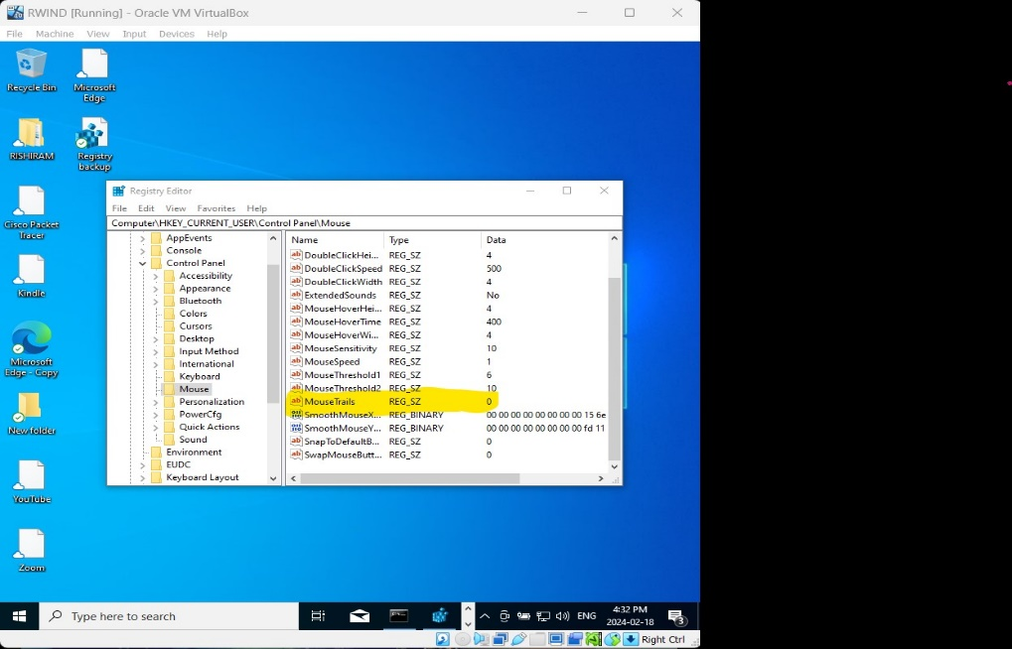
3- Back up the Mouse registry entry.
a) In the left pane, select Mouse.
b) Select File→Export.
c) In the Export Registry File dialog box, in the default location, save the file as MouseBkup.reg
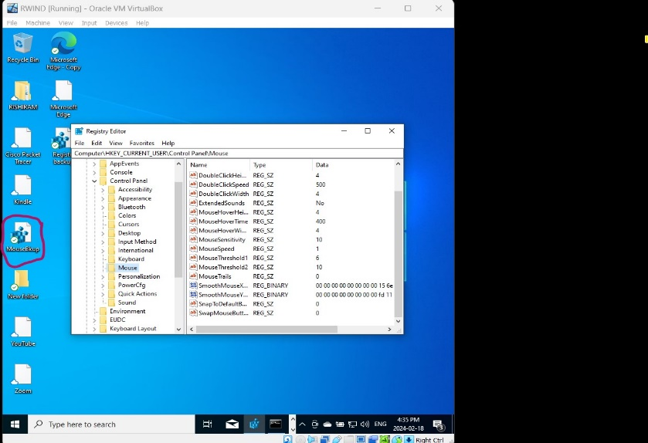

4-Change the Mouse Trail setting in Control Panel.
- Open Control Panel.
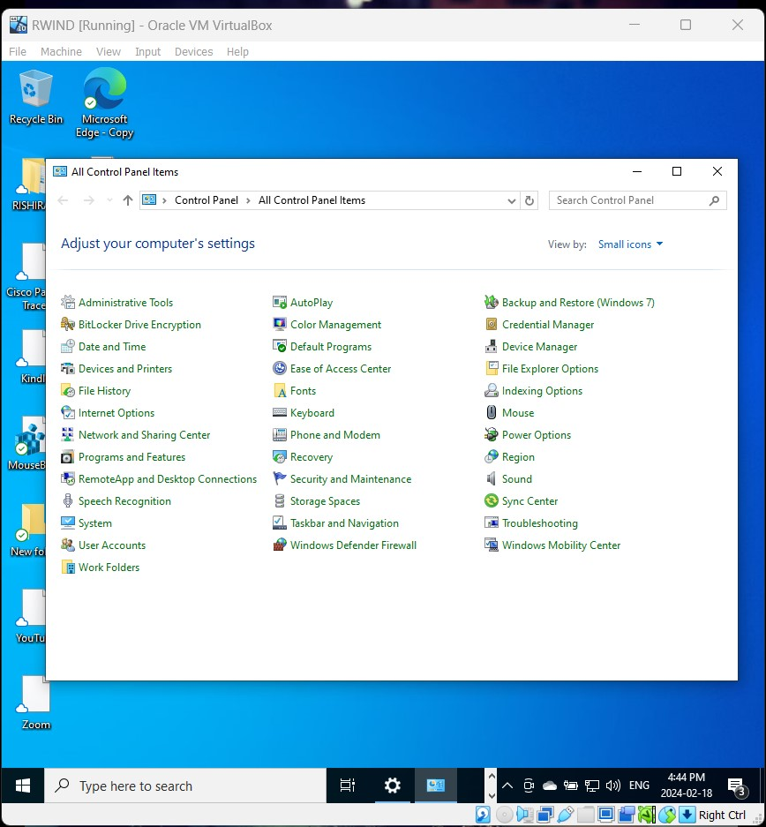

- Select Mouse.
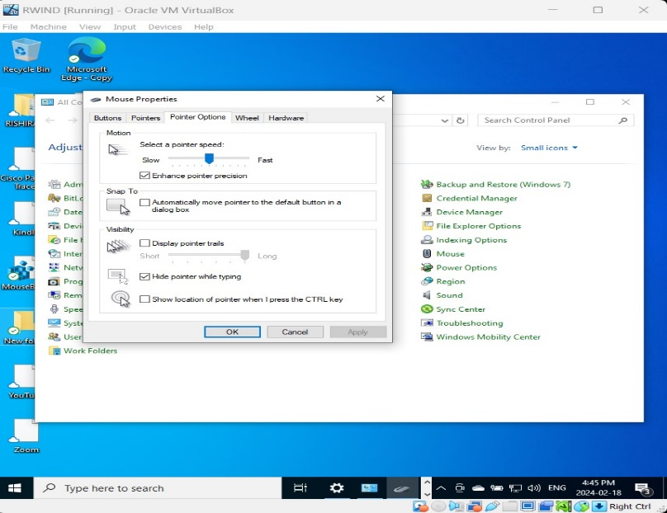

- On the Pointer Options tab, check Display pointer trails and then select OK.
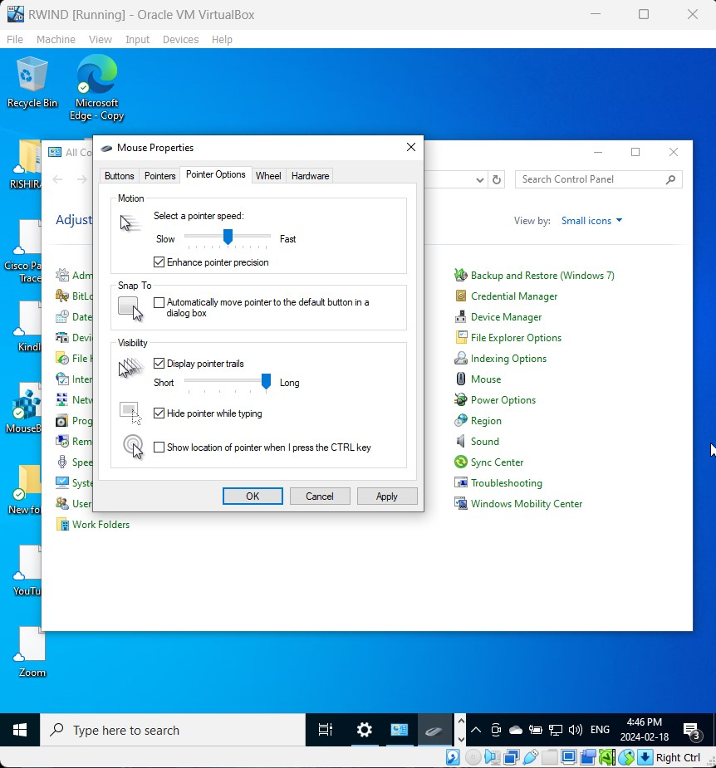

5-View the value in Registry Editor.
a) In the left pane of Registry Editor, collapse Control Panel then expand it again.
b) Select Mouse.
c) Observe the value for MouseTrails. The value has changed to 7. 5. Set Mouse Trails to your preferred setting in Control Panel.
